1. Home Page

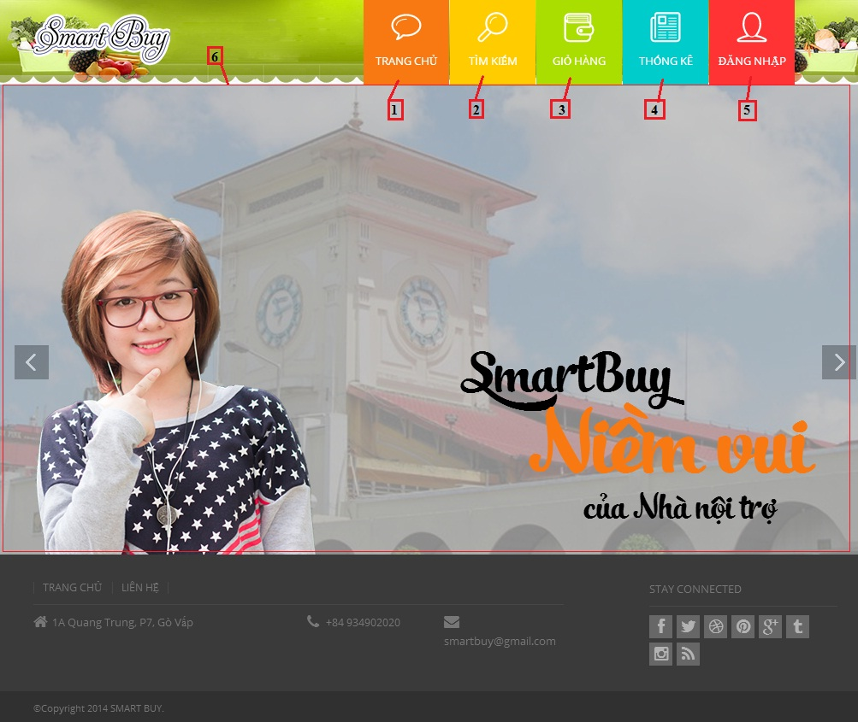

**Fields**

|  |  |  |  |  |  |  |  |
| --- | --- | --- | --- | --- | --- | --- | --- |
| **No** | **Field Name** | **Description** | **Read only** | **Mandatory** | **Control Type** | **Data Type** | **Length** |
| 6 | Slide | Silde about website | No | No | Slide | N/A | N/A |

**Button/ Hyperlink**

|  |  |  |  |  |
| --- | --- | --- | --- | --- |
| **No** | **Function** | **Description** | **Validation** | **Outcome** |
| 1 | Home page | Click to transfer to home page | No | Transfer to Home page |
| 2 | Search product | Click to transfer to search page | No | Transfer to Search page |
| 3 | View cart | Click to view cart | No | Transfer to Cart page |
| 4 | View Statistic | Click to transfer to statistic page | No | Transfer to Statistic page |
| 5 | Login page | Click to transfer to Login page | No | Transfer to Login page |

1. Home page ( Logged-In)

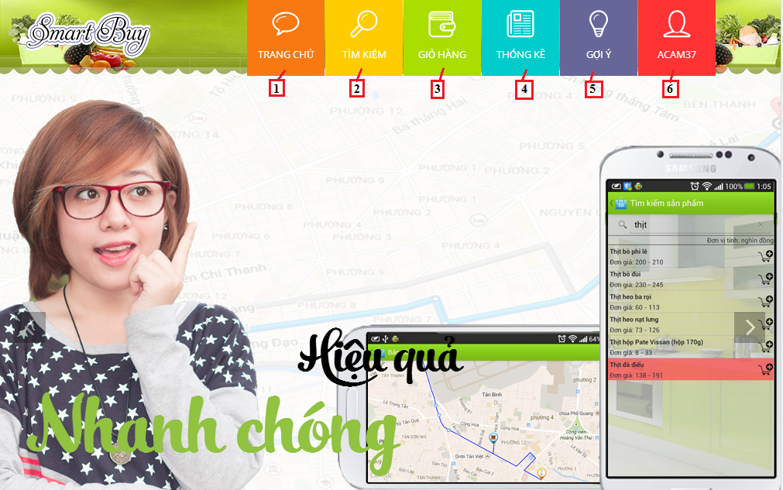

**Button/ Hyperlink**

|  |  |  |  |  |
| --- | --- | --- | --- | --- |
| **No** | **Function** | **Description** | **Validation** | **Outcome** |
| 1 | Home page | Click to transfer to home page | No | Transfer to Home page |
| 2 | Search product | Click to transfer to search page | No | Transfer to Search page |
| 3 | View cart | Click to view cart | No | Transfer to Cart page |
| 4 | View Statistic | Click to transfer to statistic page | No | Transfer to Statistic page |
| 5 | Suggest route | Click to transfer to Suggest route | No | Transfer to Suggest page |
| 6 | Account Detail | Click to transfer to account detail page | No | Transfer to Account detail page |

1. **Login Page**

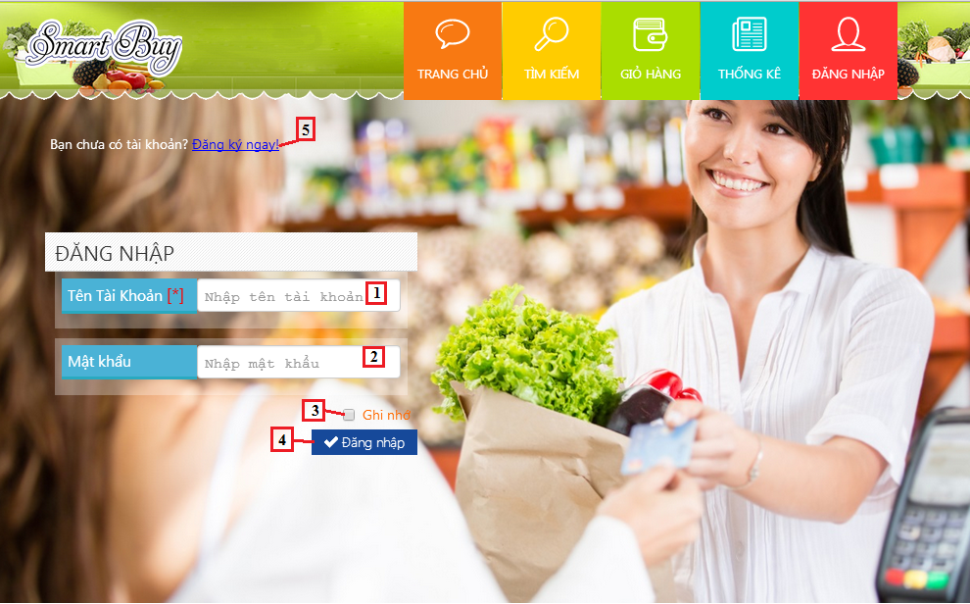

**Fields**

|  |  |  |  |  |  |  |  |
| --- | --- | --- | --- | --- | --- | --- | --- |
| **No** | **Field Name** | **Description** | **Read only** | **Mandatory** | **Control Type** | **Data Type** | **Length** |
| 1 | Account name | Fill account name | No | Yes | Textbox | String | N/A |
| 2 | Password | Fill password | No | Yes | Password | String | N/A |

**Button/ Hyperlink**

|  |  |  |  |  |
| --- | --- | --- | --- | --- |
| **No** | **Function** | **Description** | **Validation** | **Outcome** |
| 3 | Remember | Click to remember username and password | N/A | N/A |
| 4 | Login | Log-in into the system | N/A | Transfer to home page |
| 5 | Register | Click to register account | N/A | Transfer to register page |

1. **Register Page**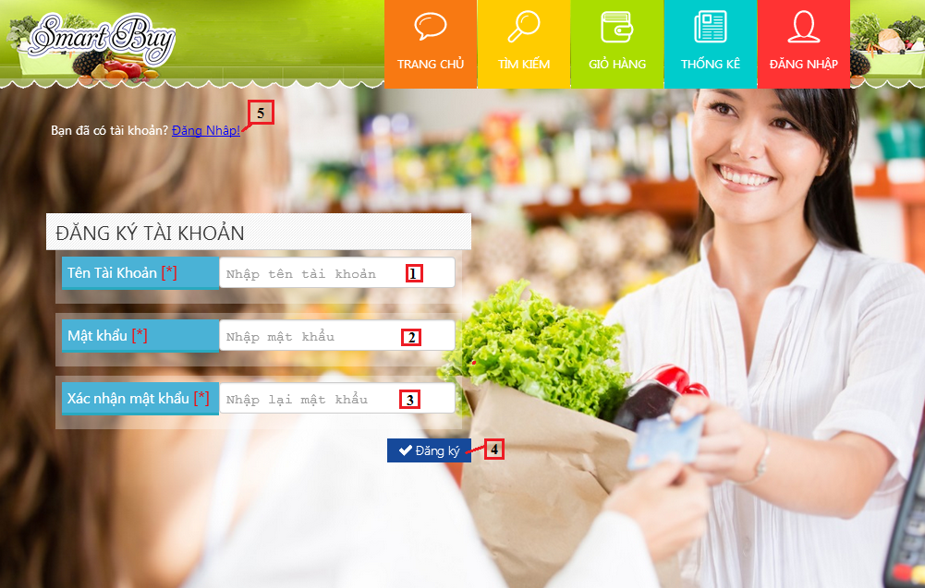

**Fields**

|  |  |  |  |  |  |  |  |
| --- | --- | --- | --- | --- | --- | --- | --- |
| **No** | **Field Name** | **Description** | **Read only** | **Mandatory** | **Control Type** | **Data Type** | **Length** |
| 1 | Account name | Fill account name | No | Yes | Textbox | String | N/A |
| 2 | Password | Fill password | No | Yes | Password | String | N/A |
| 3 | Confirm password | Fill password | No | Yes | Password | String | N/A |

**Button/ Hyperlink**

|  |  |  |  |  |
| --- | --- | --- | --- | --- |
| **No** | **Function** | **Description** | **Validation** | **Outcome** |
| 4 | Register | Register new account | N/A | Transfer to home page |
| 5 | Login | Click to log-in into the system | N/A | Transfer to login page |

1. Search Page  
   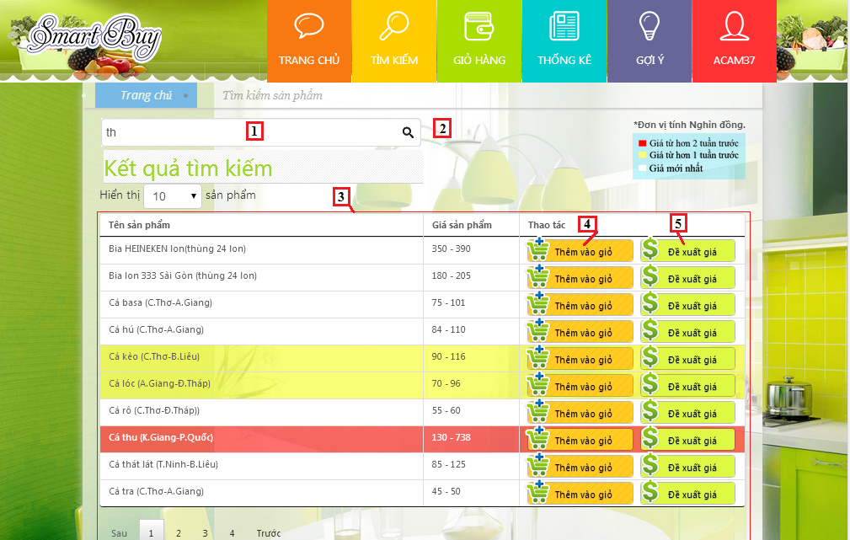

**Fields**

|  |  |  |  |  |  |  |  |
| --- | --- | --- | --- | --- | --- | --- | --- |
| **No** | **Field Name** | **Description** | **Read only** | **Mandatory** | **Control Type** | **Data Type** | **Length** |
| 2 | Product name | Fill product name | No | No | Textbox | String | N/A |
| 3 | Product list | Show list product | Yes | N/A | Table list view | N/A | N/A |

**Button/ Hyperlink**

|  |  |  |  |  |
| --- | --- | --- | --- | --- |
| **No** | **Function** | **Description** | **Validation** | **Outcome** |
| 1 | Search | Click to search | N/A | N/A |
| 4 | Add to cart | Add product to cart | N/A | N/A |
| 5 | Propose price | Click to propose price | N/A | Show pop-up propose product price |

**Product List includes**

|  |  |  |  |  |  |
| --- | --- | --- | --- | --- | --- |
| **Field Name** | **Description** | **Read only** | **Control Type** | **Data Type** | **Length** |
| Product name | Show product name | N/A | Lable | String | N/A |
| Price | Show product price | N/A | Lable | Integer | N/A |
| Action | Action for product | N/A | Button | N/A | N/A |

1. Propose Price

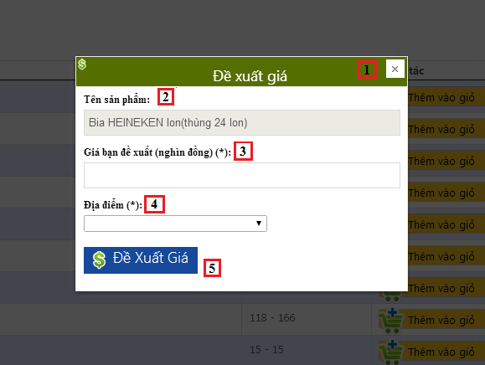

**Fields**

|  |  |  |  |  |  |  |  |
| --- | --- | --- | --- | --- | --- | --- | --- |
| **No** | **Field Name** | **Description** | **Read only** | **Mandatory** | **Control Type** | **Data Type** | **Length** |
| 1 | Propose Product price | Fill propose product price. | N/A | N/A | Label | String | N/A |
| 2 | Propose Product price | Fill product name | Yes | N/A | Textbox | String | N/A |
| 3 | Propose product price | Fill product price | No | Yes | Textbox | Integer | 1-10000 |
| 4 | Market name | Select market name | No | Yes | Dropdown list | String | N/A |

**Button/ Hyperlink**

|  |  |  |  |  |
| --- | --- | --- | --- | --- |
| **No** | **Function** | **Description** | **Validation** | **Outcome** |
| 5 | Propose price | Click to propose price | N/A | Close propose product price pop-up |

1. View Cart

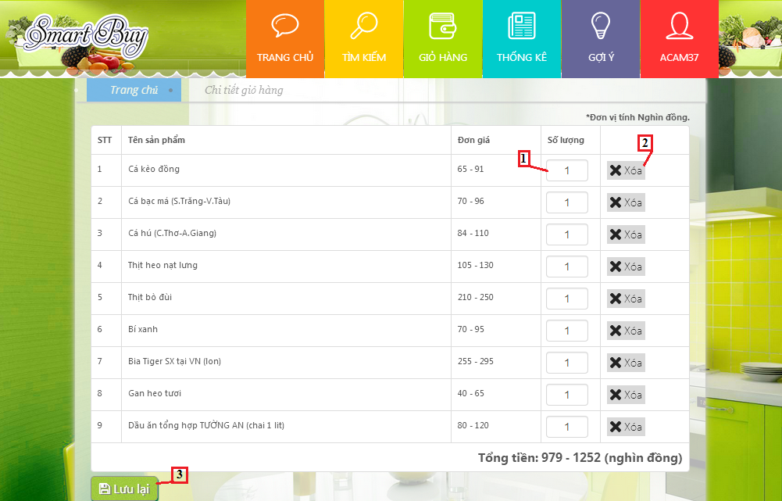

**Fields**

|  |  |  |  |  |  |  |  |
| --- | --- | --- | --- | --- | --- | --- | --- |
| **No** | **Field Name** | **Description** | **Read only** | **Mandatory** | **Control Type** | **Data Type** | **Length** |
| 1 | Quantity product | Fill product quantity | No | N/A | Textbox | Integer | [1-10] |

**Button/ Hyperlink**

|  |  |  |  |  |
| --- | --- | --- | --- | --- |
| **No** | **Function** | **Description** | **Validation** | **Outcome** |
| 2 | Delete | Click to remove product | N/A | N/A |
| 3 | Save | Save cart to history | N/A | Transfer to buying history |

**Product List includes**

|  |  |  |  |  |  |
| --- | --- | --- | --- | --- | --- |
| **Field Name** | **Description** | **Read only** | **Control Type** | **Data Type** | **Length** |
| Number row | Number of row | N/A | Lable | String | N/A |
| Product name | Show product name | N/A | Lable | String | N/A |
| Price | Show product price | N/A | Lable | Integer | N/A |
| Quantity | Show quantity of product | No | Textbox | Integer | N/A |
| Action | Action for product | N/A | Button | N/A | N/A |

1. Buying History

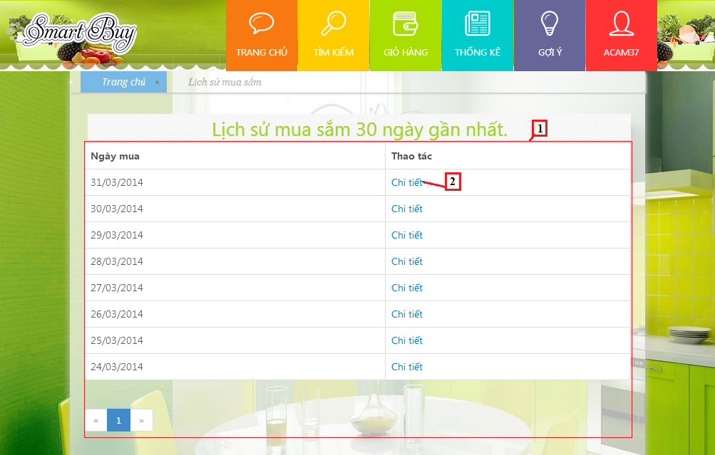

**Fields**

|  |  |  |  |  |  |  |  |
| --- | --- | --- | --- | --- | --- | --- | --- |
| **No** | **Field Name** | **Description** | **Read only** | **Mandatory** | **Control Type** | **Data Type** | **Length** |
| 1 | Buying history | Show list order history | N/A | N/A | Table list view | N/A | N/A |

**Button/ Hyperlink**

|  |  |  |  |  |
| --- | --- | --- | --- | --- |
| **No** | **Function** | **Description** | **Validation** | **Outcome** |
| 2 | Detail | Click to view order detail | N/A | Transfer to order detail page |

**Order History List includes**

|  |  |  |  |  |  |
| --- | --- | --- | --- | --- | --- |
| **Field Name** | **Description** | **Read only** | **Control Type** | **Data Type** | **Length** |
| Date | Show date order | N/A | Lable | String | N/A |
| Action | View order detail | N/A | Button | N/A | N/A |

1. Order Detail

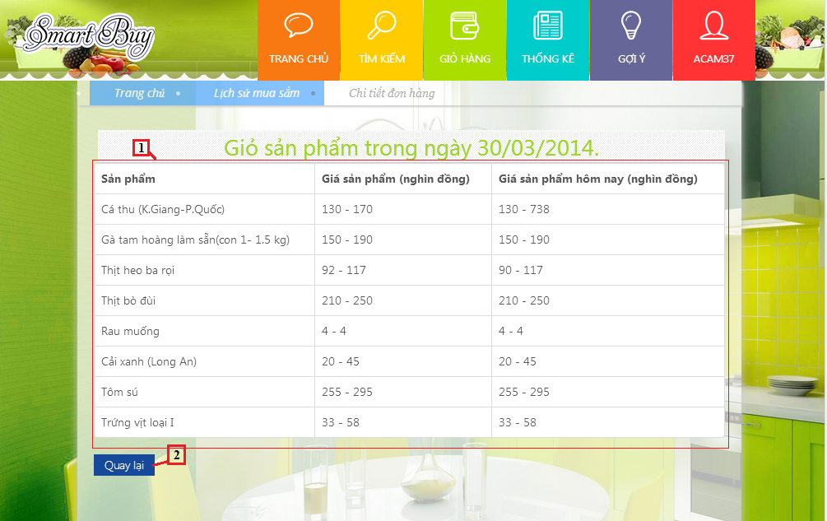

**Fields**

|  |  |  |  |  |  |  |  |
| --- | --- | --- | --- | --- | --- | --- | --- |
| **No** | **Field Name** | **Description** | **Read only** | **Mandatory** | **Control Type** | **Data Type** | **Length** |
| 1 | Order history | Show list product | N/A | N/A | Table list view | N/A | N/A |

**Button/ Hyperlink**

|  |  |  |  |  |
| --- | --- | --- | --- | --- |
| **No** | **Function** | **Description** | **Validation** | **Outcome** |
| 2 | Back | Back to order history page | N/A | Transfer to order history page |

**Order Product List includes**

|  |  |  |  |  |  |
| --- | --- | --- | --- | --- | --- |
| **Field Name** | **Description** | **Read only** | **Control Type** | **Data Type** | **Length** |
| Product name | Show product name | N/A | Lable | String | N/A |
| Product price | Show product price | N/A | Lable | Integer | N/A |
| Product current price | Show current price | N/A | Lable | Integer | N/A |

1. Suggest Route

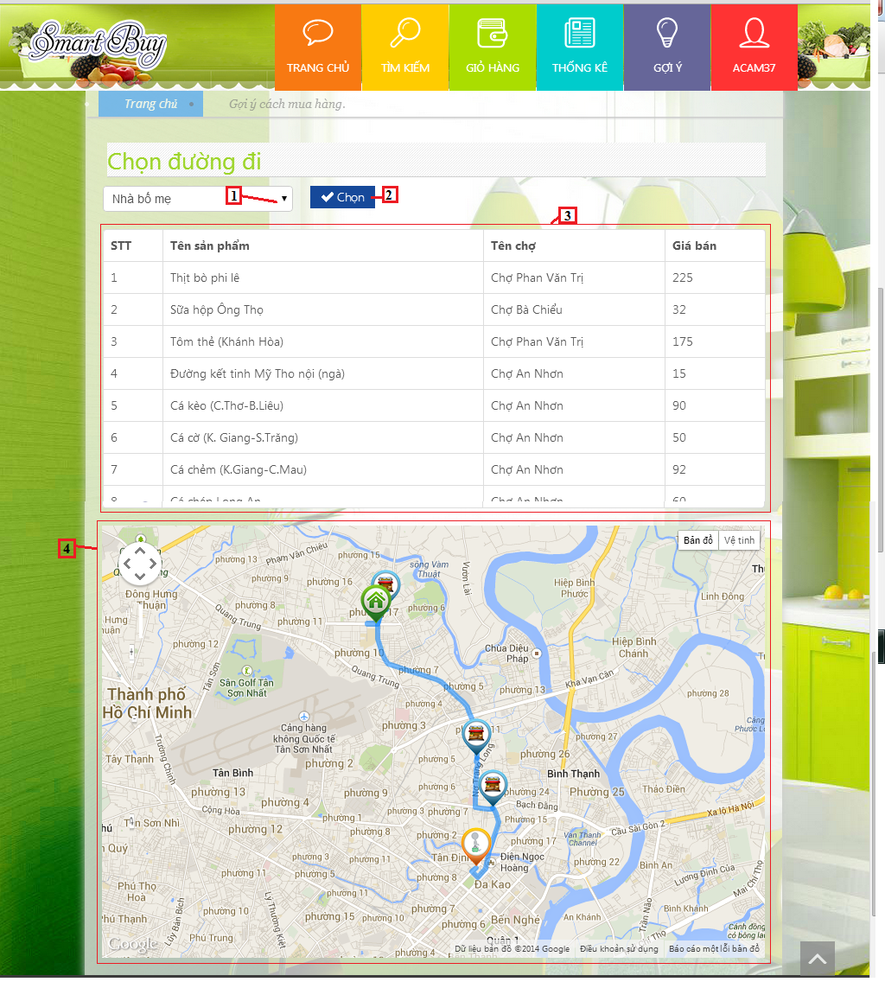

**Fields**

|  |  |  |  |  |  |  |  |
| --- | --- | --- | --- | --- | --- | --- | --- |
| **No** | **Field Name** | **Description** | **Read only** | **Mandatory** | **Control Type** | **Data Type** | **Length** |
| 1 | Route | Address name | Yes | N/A | Dropdown list | String | N/A |
| 3 | Order detail | Show list product | Yes | N/A | Table list view | N/A | N/A |
| 4 | Map | Show map suggest | Yes | N/A | Google map | N/A | N/A |

**Button/ Hyperlink**

|  |  |  |  |  |
| --- | --- | --- | --- | --- |
| **No** | **Function** | **Description** | **Validation** | **Outcome** |
| 2 | Suggest route | Click to view map | N/A | Show map |

**Order Detail includes**

|  |  |  |  |  |  |
| --- | --- | --- | --- | --- | --- |
| **Field Name** | **Description** | **Read only** | **Control Type** | **Data Type** | **Length** |
| STT | Number row | N/A | Lable | Integer | N/A |
| Product name | Show product name | N/A | Lable | String | N/A |
| Market name | Show market name | N/A | Lable | String | N/A |
| Product price | Show current price | N/A | Lable | Integer | N/A |

1. Account detail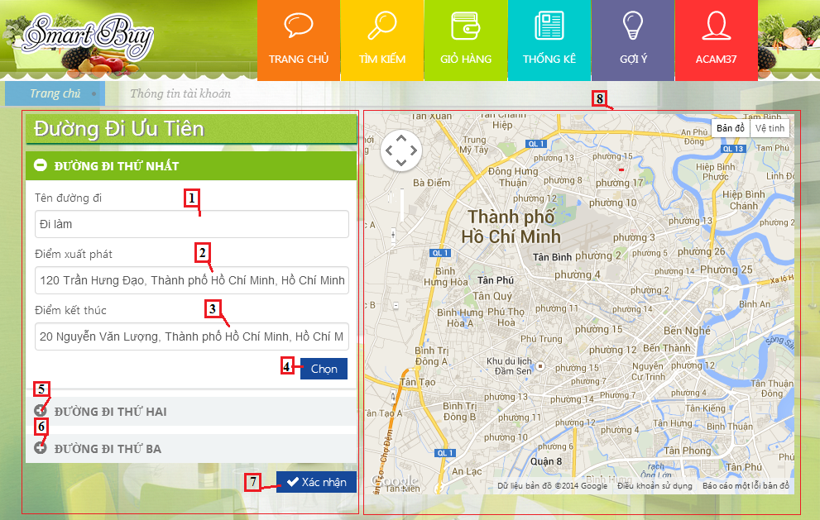

**Fields**

|  |  |  |  |  |  |  |  |
| --- | --- | --- | --- | --- | --- | --- | --- |
| **No** | **Field Name** | **Description** | **Read only** | **Mandatory** | **Control Type** | **Data Type** | **Length** |
| 1 | Route name | Route’s name | No | Yes | Textbox | String | N/A |
| 2 | Start route | Address of start route | No | Yes | Textbox | String | N/A |
| 3 | End route | Address of end route | No | Yes | Textbox | String | N/A |
| 8 | Map | Show route on map | N/A | N/A | Google map | N/A | N/A |

**Button/ Hyperlink**

|  |  |  |  |  |
| --- | --- | --- | --- | --- |
| **No** | **Function** | **Description** | **Validation** | **Outcome** |
| 4 | Choose | Show route on map | N/A | N/A |
| 5 | Route second | Show info detail of route second | N/A | N/A |
| 6 | Route three | Show info detail of route three | N/A | N/A |
| 7 | Save | Save info detail of address | N/A | N/A |

1. **Change Password**

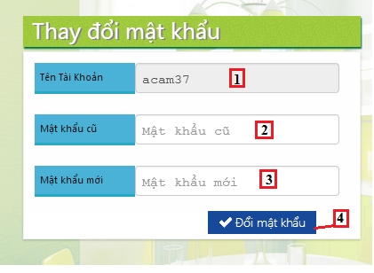

**Fields**

|  |  |  |  |  |  |  |  |
| --- | --- | --- | --- | --- | --- | --- | --- |
| **No** | **Field Name** | **Description** | **Read only** | **Mandatory** | **Control Type** | **Data Type** | **Length** |
| 1 | User name | Fill account name | No | Yes | Textbox | String | N/A |
| 2 | Old password | Fill old password | No | Yes | Textbox | String | N/A |
| 3 | New password | Fill new password | No | Yes | Textbox | String | N/A |

**Button/ Hyperlink**

|  |  |  |  |  |
| --- | --- | --- | --- | --- |
| **No** | **Function** | **Description** | **Validation** | **Outcome** |
| 4 | Save | Change old password | N/A | Transfer to Account detail |